**I3308**

**Final Year Project**

Name: NeuraSent

***NeuraSent: Deep learning for sentiment analysis***

**Karim Yazbeck - 58128**

**Elio Khawand – 58563**

**Supervisor: *Dr* *Manal El Dick***

Table of Contents

Introduction: 2

Bibliography 3

Analysis 5

**Business rules** 5

Algorithms 6

Mathematical Foundations of the Models 7

LinearSVC: 7

Development 8

Conclusion 18

# Introduction:

Have you ever wondered what your customers think and feel about your products or services? Do you want to know how to improve your offerings and increase customer loyalty? Do you want to discover the best products to buy in any category based on real customer feedback?

If you answered yes to any of these questions, then you will love our sentiment analysis website project. This project is designed to provide you with valuable insights about customer sentiments and opinions by analyzing online reviews and social media data. You will be able to see how many positive and negative reviews each product has, along with its title and image. You will also be able to search for any product or category on Amazon.com and get the relevant results in seconds.

Our website is powered by Flask, a lightweight web framework for Python that allows us to create web applications and APIs with ease and flexibility. We use Flask to handle user requests, communicate with Amazon’s website, process the scraped data, and render the HTML templates for our website’s pages. We also use a sentiment analysis model that can classify the reviews as positive or negative based on natural language processing techniques.

We have successfully completed our project and we are proud of our achievements. We have tested our website and our sentiment analysis model on various products from Amazon and eBay, and we have obtained satisfactory results. We are excited to share our project with you and help you gain more insights into customer sentiments and opinions.

# Bibliography

Our sentiment analysis project is a unique and innovative solution in the field. We created our own sentiment analysis model using linearSVC, a fast and simple model that can achieve good results on our data without compromising on quality or performance. We chose this model after reviewing and studying various approaches and models for sentiment analysis, and comparing them based on their performance, complexity, cost, and scalability. We tested different models on various products from Amazon and eBay, and we analyzed the results. We used the following sources to learn more about sentiment analysis and linearSVC:

* Bird, S., Klein, E., & Loper, E. (2009). Natural language processing with Python: Analyzing text with the natural language toolkit. O’Reilly Media
* Devlin, J., Chang, M.-W., Lee, K., & Toutanova, K. (2019). BERT: Pre-training of deep bidirectional transformers for language understanding. In Proceedings of the 2019 Conference of the North American Chapter of the Association for Computational Linguistics: Human Language Technologies (pp. 4171–4186). Association for Computational Linguistics.
* Grinberg, M. (2018). Flask web development: Developing web applications with Python (2nd ed.). O’Reilly Media.
* Hochreiter, S., & Schmidhuber, J. (1997). Long short-term memory. Neural Computation, 9(8), 1735–1780.
* OpenAI Platform. (2023). OpenAI platform. <https://platform.openai.com/docs/models/chatgpt>
* Python Programming Tutorials. (n.d.). Linear SVC example with scikit-learn. <https://pythonprogramming.net/linear-svc-example-scikit-learn-svm-python/>
* scikit-learn developers. (2021). sklearn.svm.LinearSVC. <https://scikit-learn.org/stable/modules/generated/sklearn.svm.LinearSVC.html>
* Sentiment Analysis: Concept, Analysis and Applications. (2016). In S. Bandyopadhyay & U. Maulik (Eds.), SpringerBriefs in Computer Science. Springer.
* Zhang, L., & Liu, B. (2018). Sentiment analysis: A survey of methods and applications. Wiley Interdisciplinary Reviews: Data Mining and Knowledge Discovery, 8(4), e1253.

# Analysis

## **Business rules**

The main objective of our sentiment analysis website is to provide users with an easy and convenient way to analyze the reviews of any product sold on Amazon.com. The website should be able to:

* Allow users to enter a keyword or a category in a search bar and retrieve the relevant products from Amazon using web scraping techniques.
* Apply a sentiment analysis model to classify the reviews of each product as positive or negative and display the number of positive and negative reviews for each product, along with its title and image.
* Provide a user-friendly interface that shows the results in a clear and attractive way.

**Some of the business rules that our website should follow are:**

* The website should validate the user input and handle any errors or exceptions gracefully.
* The website should respect the terms and conditions of Amazon and not violate any ethical or legal issues when scraping data from its website.
* The website should use a reliable and accurate sentiment analysis model that can handle informal and noisy texts and different languages and domains.

## Algorithms

There are many existing methods and models for sentiment analysis, ranging from simple lexicon-based approaches to complex deep learning architectures.

However, there is no one-size-fits-all solution for sentiment analysis, as different tasks and domains may require different techniques and features.

That is why we are constantly exploring and experimenting with various approaches and models to find the best one for our website. We want to provide our users with accurate and reliable results that reflect the true sentiments and opinions of customers.

We have chosen linearSVC, which is a supervised learning model that can classify the reviews as positive or negative based on a linear function. We have also compared linearSVC with other models, such as LSTM, BERT, and transformers, which are based on neural networks and can capture more complex and contextual features from the text. One of the reasons we did not use the other models is that they would incur high costs for our data processing, as the GPUs and TPUs available for free on the cloud are not sufficient for their training and inference.

These models also require more time and memory to run, which would limit our scalability and efficiency. Therefore, we opted for linearSVC, which is a fast and simple model that can achieve good results on our data without compromising on quality or performance.

## Mathematical Foundations of the Models

In this section, we will describe the mathematical foundations of the model we have used for sentiment analysis. We will focus on the main equations and concepts that define the model, without going into too much detail.

## LinearSVC:

LinearSVC is a linear support vector classifier, which is a supervised learning model that can classify the reviews as positive or negative based on a linear function. The objective function of LinearSVC is to minimize the hinge loss function, which is defined as:

$$L(w,b)=n1​i=1∑n​max(0,1-yi​(wTxi​+b))+λ∥w∥2$$

where w is the weight vector, b is the bias term, xi​ is the feature vector of the i-th review, yi​ is the true label of the i-th review (+1 for positive, -1 for negative), n is the number of reviews, and λ is the regularization parameter. The hinge loss function penalizes predictions that are on the wrong side of the margin or too close to it. The regularization term prevents overfitting by shrinking the weight vector.

# Development

During the development phase of our sentiment analysis website, we focused on implementing the key functionalities and ensuring a smooth user experience. Here are the main aspects of our development process:

* Website Architecture: We built our website using Flask, a lightweight web framework for Python. Flask allowed us to handle user requests, communicate with external APIs (such as Amazon's website), process scraped data, and render HTML templates for our website's pages. The modular structure of Flask facilitated the development process and made it easier to maintain and extend our website in the future.
* Web Scraping: To retrieve product information and customer reviews from Amazon.com, we employed web scraping techniques. We utilized Python libraries like BeautifulSoup and Requests to extract data such as product titles, images, and reviews. Our web scraping code was designed to handle different search queries and collect relevant information efficiently.

To scrape data from Amazon.com, we followed these steps:

* + We imported the BeautifulSoup and Requests libraries in Python. The BeautifulSoup library helps to parse HTML data and extract information from web pages. The Requests library helps to send HTTP requests and receive responses from web pages.
  + We defined a function that takes a search query as an argument and returns a list of product URLs from Amazon.com. The function uses the Requests library to send a GET request to the Amazon.com search page with the query as a parameter. The function then uses the BeautifulSoup library to parse the response and find the product URLs from the HTML elements. The function also handles pagination and returns up to 10 product URLs per query.
  + We defined another function that takes a product URL as an argument and returns a dictionary of product information and customer reviews. The function uses the Requests library to send a GET request to the product page and the BeautifulSoup library to parse the response. The function then extracts data such as product title, image, price, rating, and reviews from the HTML elements. The function also handles different formats and layouts of product pages and returns consistent data.
  + We applied the first function to each search query in our dataset using the apply method. The function returned a list of product URLs for each query. We then applied the second function to each product URL in the list using a nested apply method. The function returned a dictionary of product information and customer reviews for each product URL. We stored the scraped data in a new column in our dataset.
* Sentiment Analysis Model: The core of our sentiment analysis functionality relied on a sentiment analysis model. We selected the linear Support Vector Classifier (LinearSVC) as our model of choice. This supervised learning model was trained on labeled data to classify reviews as either positive or negative. We implemented the LinearSVC model using Python libraries like scikit-learn. The model was trained in a diverse dataset of customer reviews to ensure accurate predictions.

To implement the LinearSVC model, we followed these steps:

* + We imported the scikit-learn library and its modules, such as LinearSVC, TfidfVectorizer, and Pipeline. The scikit-learn library provides tools for machine learning in Python. The LinearSVC module implements the LinearSVC model. The TfidfVectorizer module transforms text into numerical features using term frequency-inverse document frequency (TF-IDF) weighting. The Pipeline module combines multiple steps into a single estimator.
  + We loaded a dataset of customer reviews from various domains, such as books, electronics, movies, etc. The dataset had two columns: the review text and the sentiment label (positive or negative). We split the dataset into training and testing sets using the train_test_split function.
  + We created a pipeline that combines the TfidfVectorizer and the LinearSVC into one estimator. The pipeline takes raw text as input and outputs a sentiment prediction. The pipeline also has some parameters that control the behavior of the TfidfVectorizer and the LinearSVC, such as the n-gram range, the regularization strength, and the maximum number of iterations.
  + We trained the pipeline on the training set using the fit method. The pipeline learned to extract features from the text and to assign a sentiment label to each review.
  + We evaluated the pipeline on the testing set using the score method. The pipeline achieved a high accuracy score, indicating that it can generalize well to new data.
* ChatGPT API: To provide an interactive and engaging feature for our website users, we integrated the ChatGPT API into our website. ChatGPT is a large language model trained by OpenAI that can generate natural language responses based on user input (OpenAI Platform, 2023). We used the OpenAI SDK, specifically the Python requests library, to communicate with the ChatGPT API. By utilizing the SDK, we were able to send requests to the API and receive responses in JSON format. This allowed us to analyze and synthesize product reviews, enabling us to assist users in making informed decisions. The chatbot, powered by the ChatGPT API, can compare different products based on sentiment scores and suggest the best product for the user's needs. We further customized the chatbot's personality and tone to align with our website's theme and purpose. The ChatGPT API has significantly enhanced our project by introducing a conversational interface that engages users and provides them with valuable information and insights.

To integrate the ChatGPT API into our website, we followed these steps:

* + We installed the OpenAI SDK, a Python library that simplifies the communication with the ChatGPT API, using the pip command: pip install OpenAI.
  + We imported the OpenAI library and set our secret key as an environment variable: import OpenAI and openai.api_key = os.getenv("OPENAI_SECRET_KEY").
  + We created a function that takes a user input as an argument and returns a response from the ChatGPT API. The function uses the openai.Completion.create method to send a request to the API and receive a response in JSON format. The function also specifies some parameters for the request, such as the engine name, the prompt, the temperature, the max tokens, and the stop sequence. The function then extracts the text from the response and returns it as a string
* Data Preprocessing: Before feeding the review data into the sentiment analysis model, we performed data preprocessing steps to enhance the model's performance. This included removing punctuation, converting text to lowercase, removing stop words, and tokenizing the text. These preprocessing techniques helped to normalize the text data and remove noise, improving the model's ability to extract sentiment.

To preprocess the review data, we followed these steps:

* + We imported the nltk library and its modules, such as word_tokenize, stopwords, and punkt. The nltk library provides tools for natural language processing in Python. The word_tokenize module splits text into tokens (words or punctuation). The stopwords module provides a list of common words that do not carry much meaning, such as “the”, “a”, “and”, etc. The punkt module is a pre-trained model for sentence boundary detection.
  + We defined a function that takes a review text as an argument and returns a preprocessed text. The function performs the following operations on the text: removing punctuation, converting text to lowercase, removing stop words, and tokenizing the text. These preprocessing techniques help to normalize the text data and remove noise, improving the model’s ability to extract sentiment.
  + We applied the function to each review in the dataset using the apply method. The function returned a list of tokens for each review. We stored the preprocessed data in a new column in the dataset.
* User Interface: We focused on creating a user-friendly interface that provided an intuitive and visually appealing experience for our website users. The interface included a search bar where users could enter keywords or categories to find relevant products. The search results displayed product details such as title, image, and the number of positive and negative reviews. The interface also presented the sentiment analysis results in a clear and attractive format, allowing users to easily interpret and analyze customer sentiments.

To create the user interface, we followed these steps:

* + We used HTML, CSS, and Bootstrap to design the layout and style of the interface. We used HTML to create the structure of the web page, such as the header, the footer, the search bar, and the search results. We used CSS to apply colors, fonts, margins, and other styling elements to the web page. We used Bootstrap to make the web page responsive and mobile-friendly.
  + We used JavaScript and jQuery, to add interactivity and functionality to the interface. We used JavaScript to manipulate the DOM elements and to handle user events, such as clicking on a button or entering a keyword. We used jQuery to simplify the JavaScript code. As well as Jinja which is a similar syntax to python that exists in the front-end to do logical functionalities and communicate with the backend server.
  + We used Flask, a web framework for Python, to create the backend server that handled the requests from the interface. The backend server used the ChatGPT API and the sentiment analysis model to generate responses and predictions based on user input. The backend server returned JSON data to the interface, which displayed it in a clear and attractive format.
* Error Handling and Validation: To ensure a robust website, we implemented error handling and validation mechanisms. This included validating user input, handling exceptions gracefully, and providing informative error messages to guide users in case of any issues. We also implemented security measures to protect user data and ensured compliance with ethical and legal considerations while scraping data from external websites.

To implement error handling and validation mechanisms, we followed these steps:

* + We used regular expressions to validate user input, such as keywords or categories, and to prevent malicious or invalid input. We used the re module in Python to create and apply regular expressions to user input. We also used the flash function in Flask to display validation messages to users, such as “Please enter a valid keyword” or “No results found for this category”.
  + We used the try-except block in Python to handle exceptions gracefully and to provide informative error messages to users in case of any issues. For example, we used the try-except block to handle the ConnectionError exception that could occur when communicating with the ChatGPT API or the sentiment analysis model. We also used the abort function in Flask to return custom error pages, such as 404 (Not Found) or 500 (Internal Server Error), with appropriate error messages, such as “Sorry, something went wrong” or “We are working on fixing this issue”.
  + We used the requests module in Python to scrape data from external websites, such as Amazon or eBay, to obtain product details and customer reviews. We ensured that we followed the ethical and legal considerations while scraping data, such as respecting the robots.txt file, limiting the number of requests per second, and providing a user agent header. We also used the BeautifulSoup module in Python to parse the HTML data and to extract the relevant information.
* **Home page:**

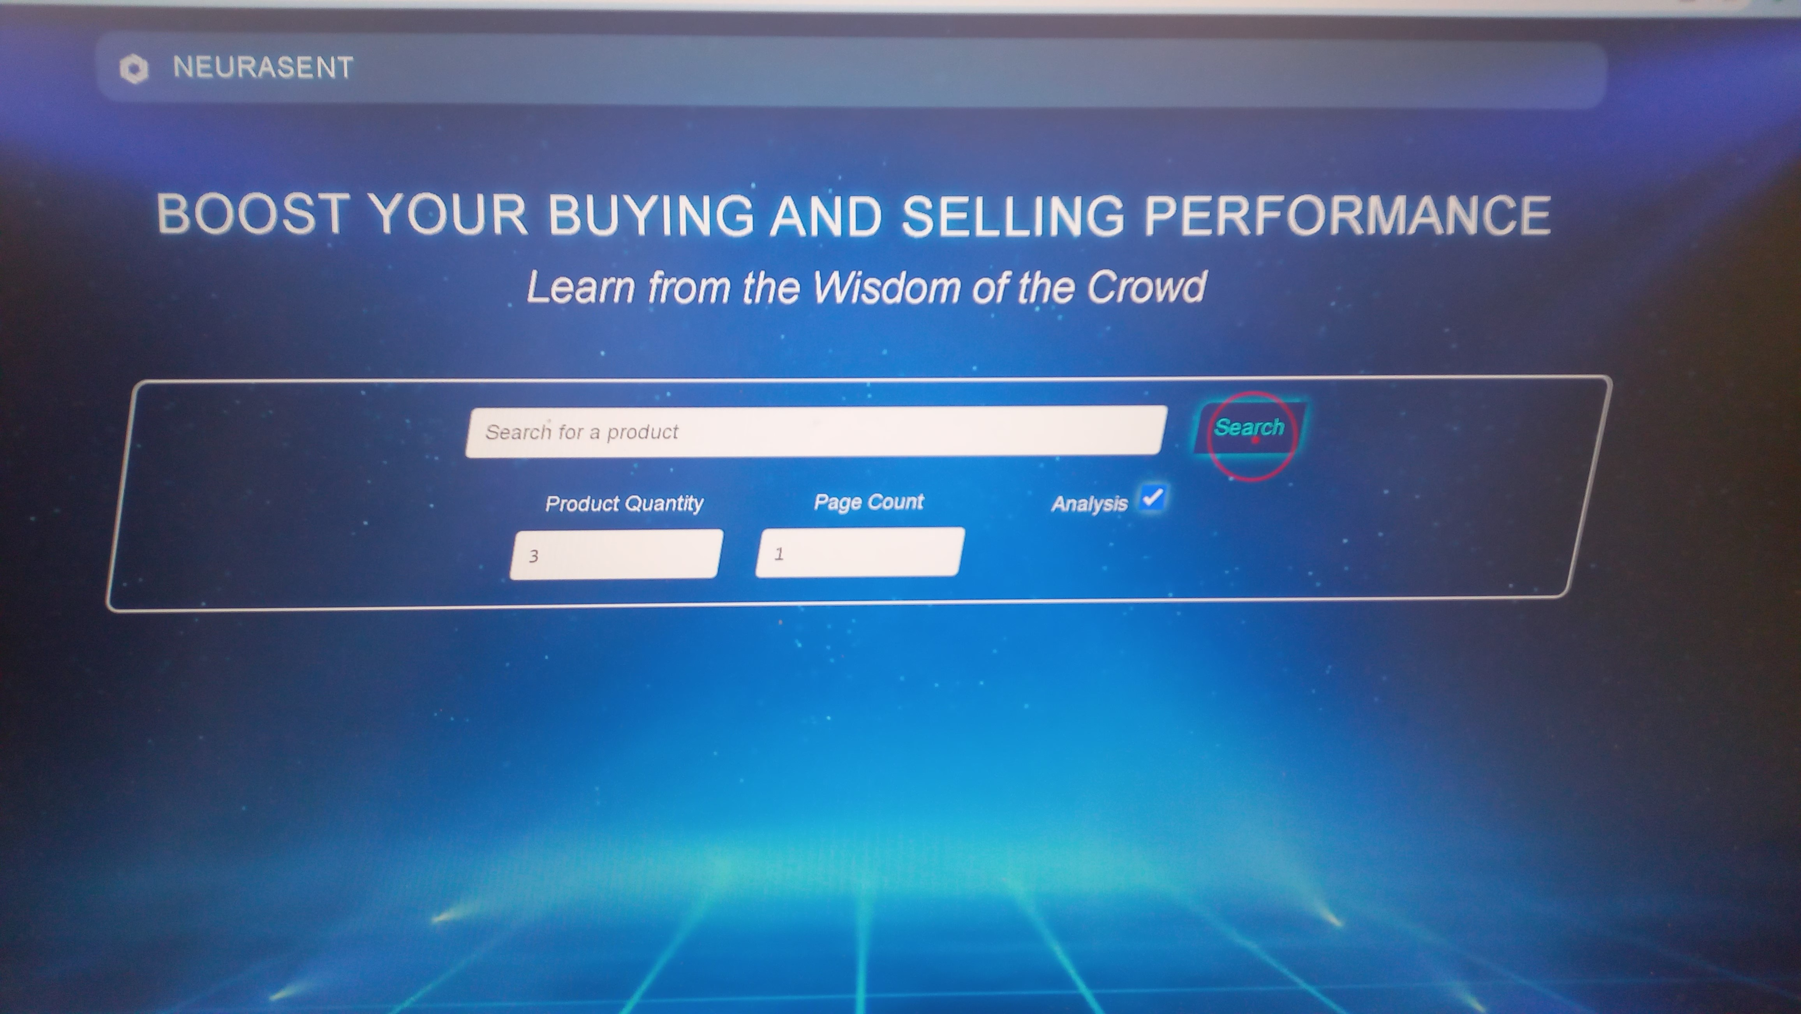

* **Home page, Our Loading Screen:**

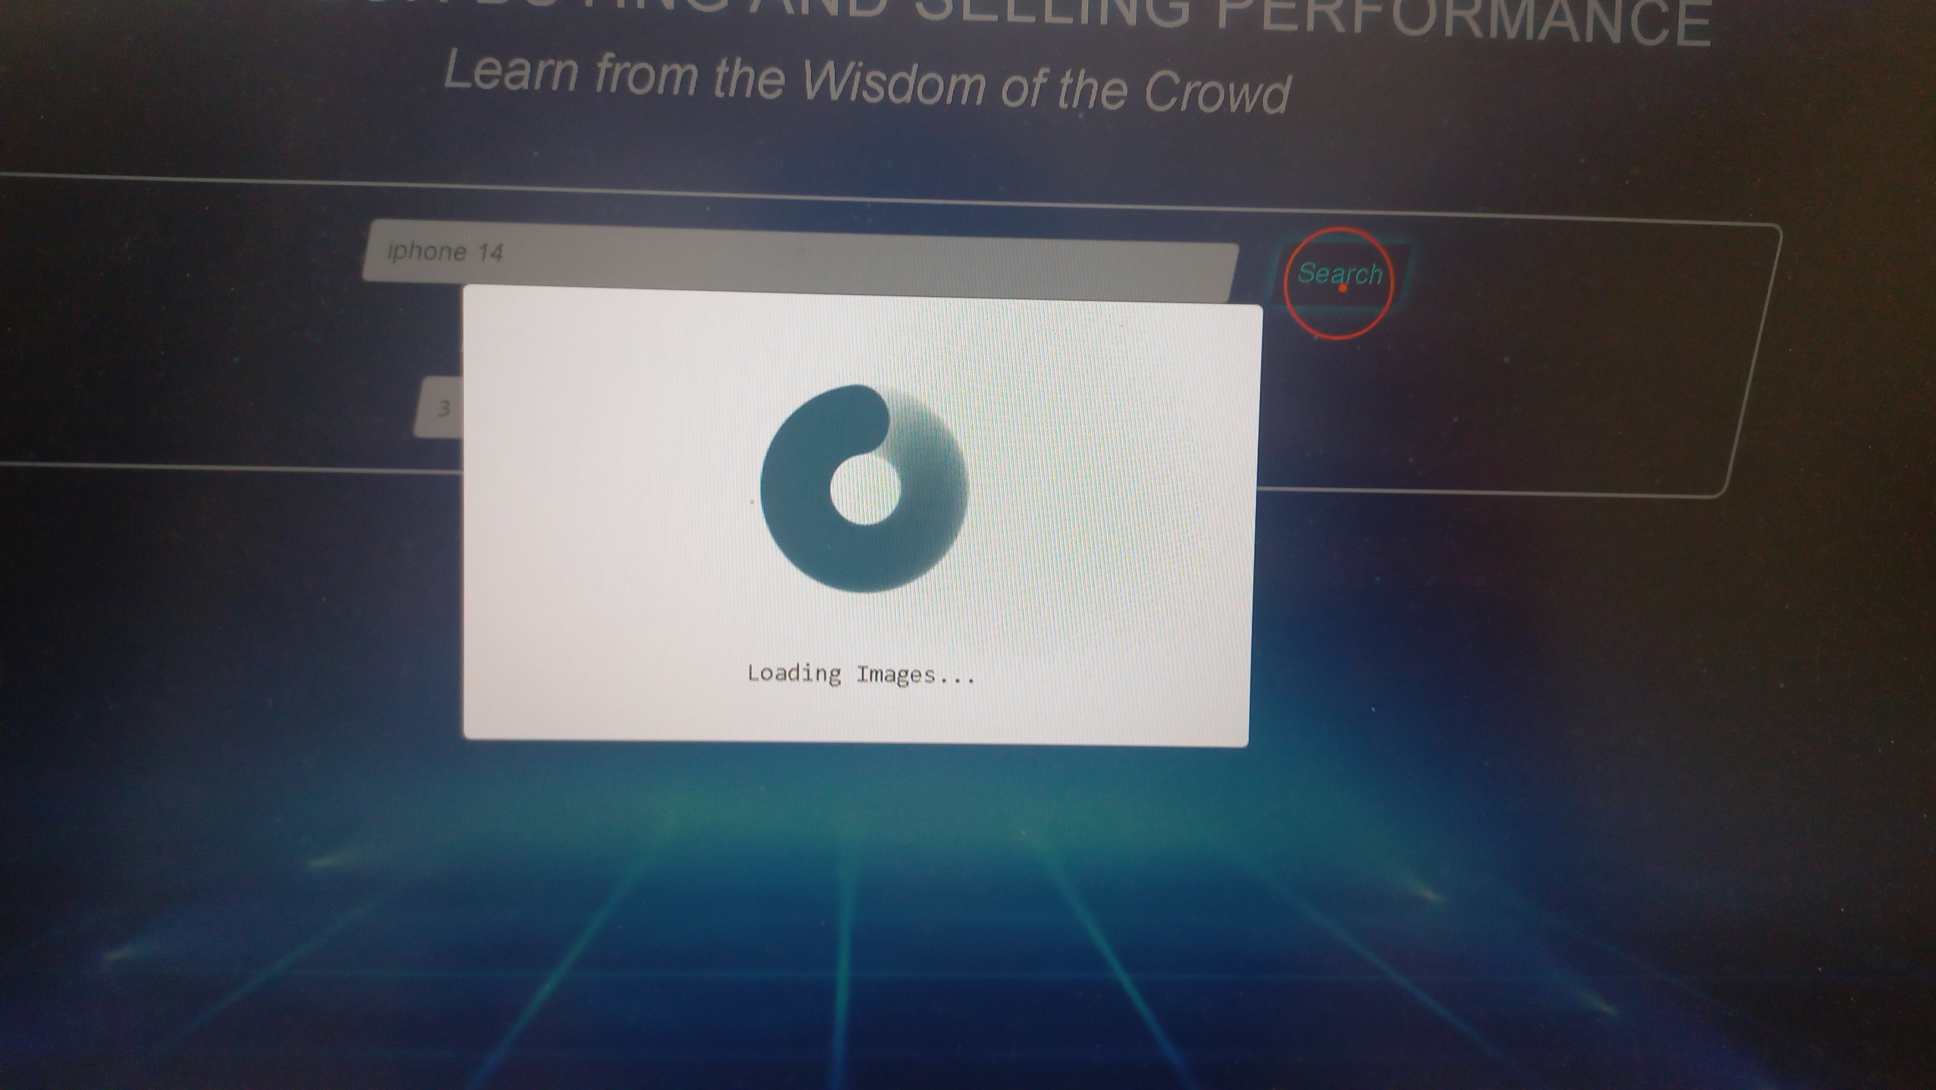

**C)Search page, with all the different screens:**

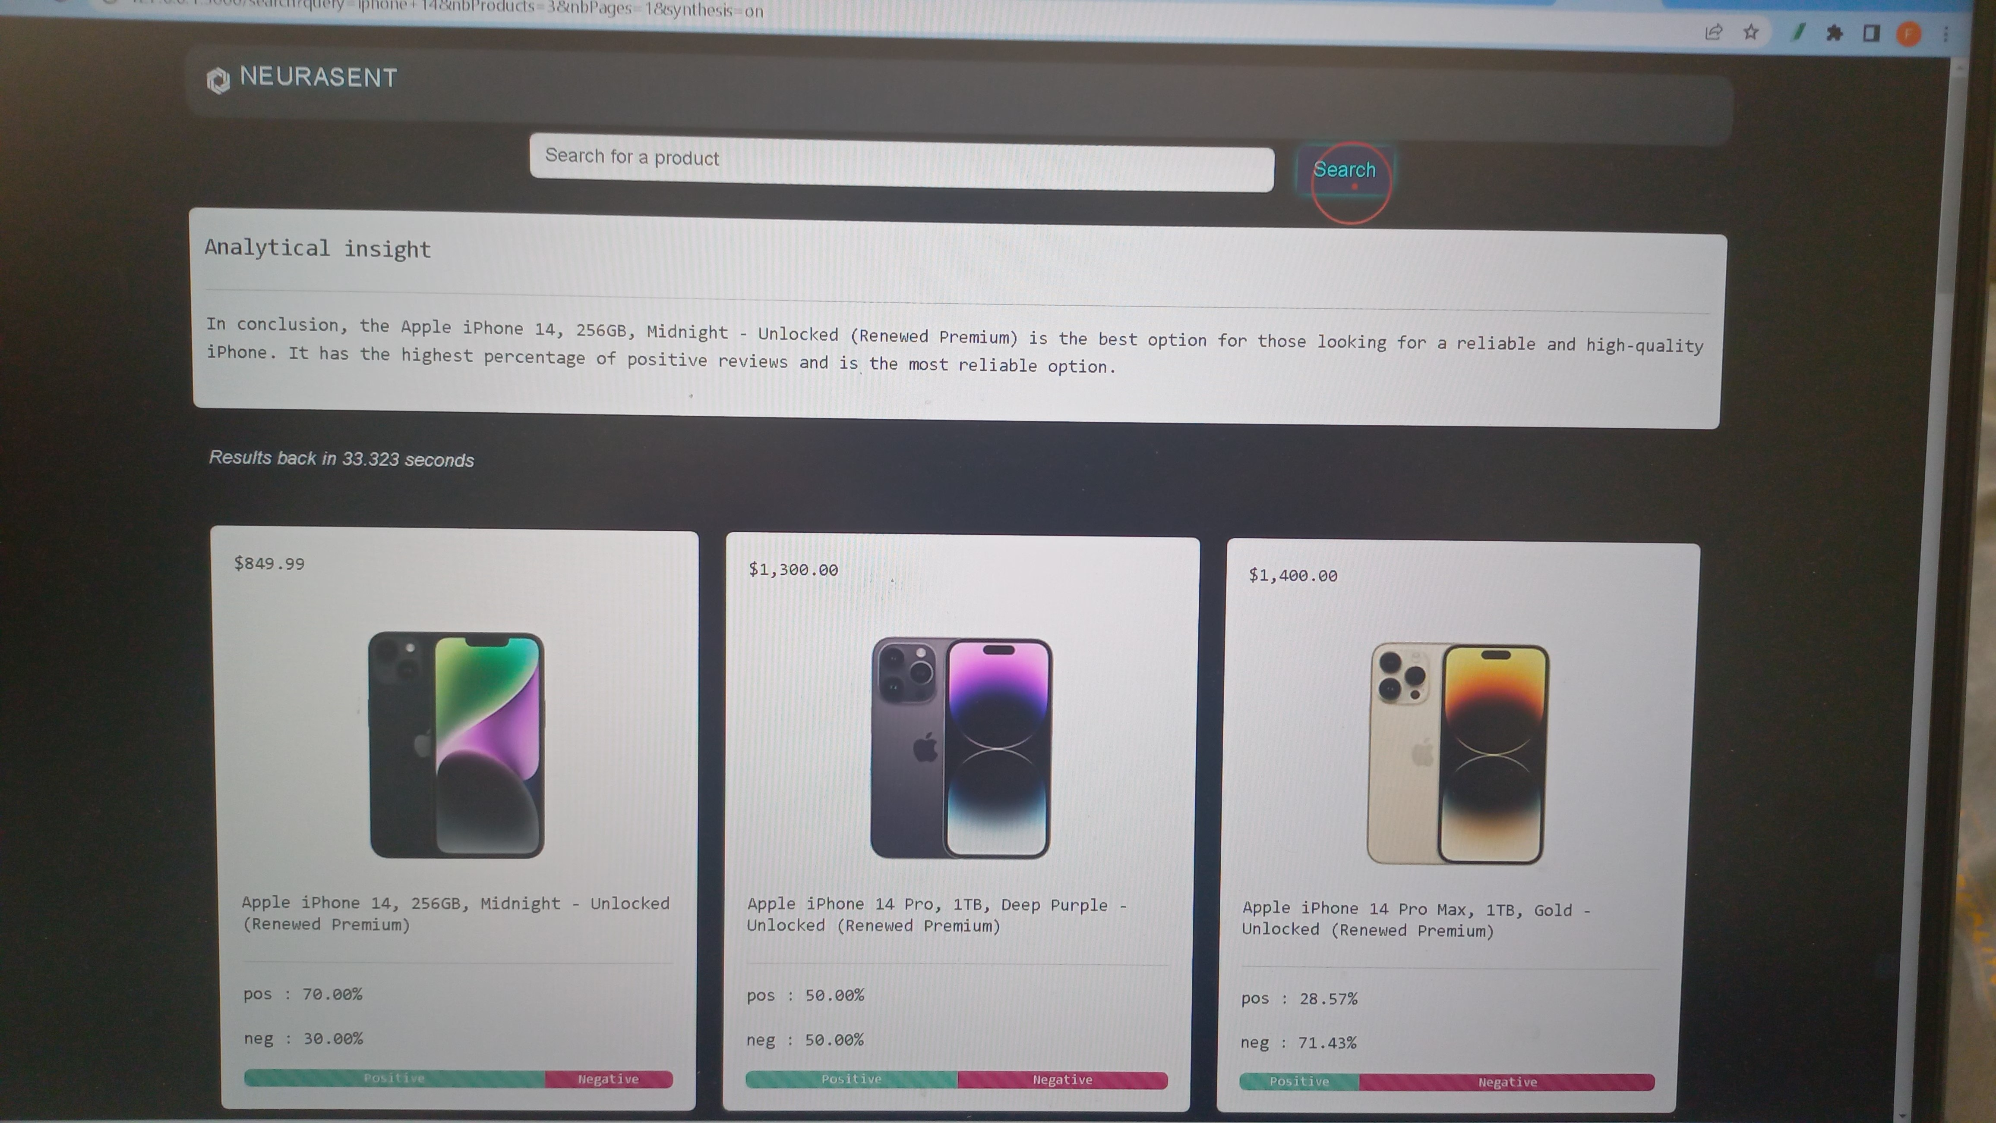

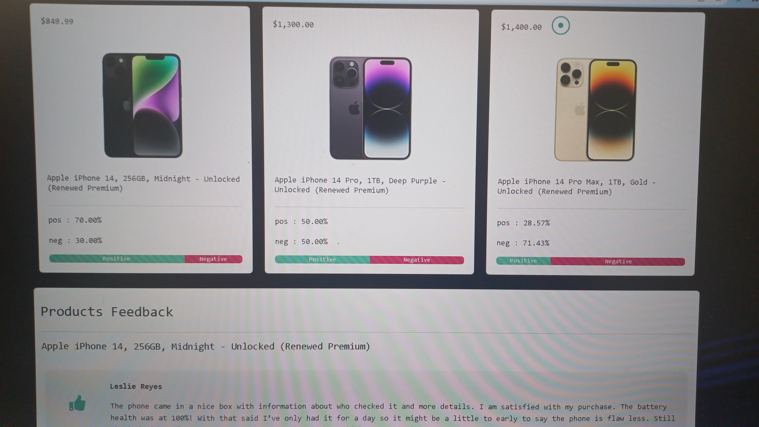

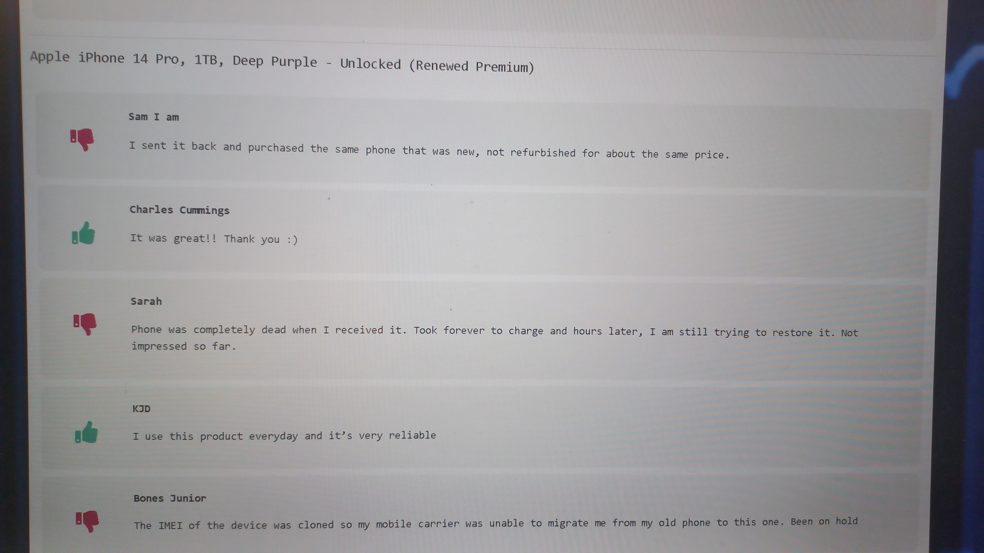

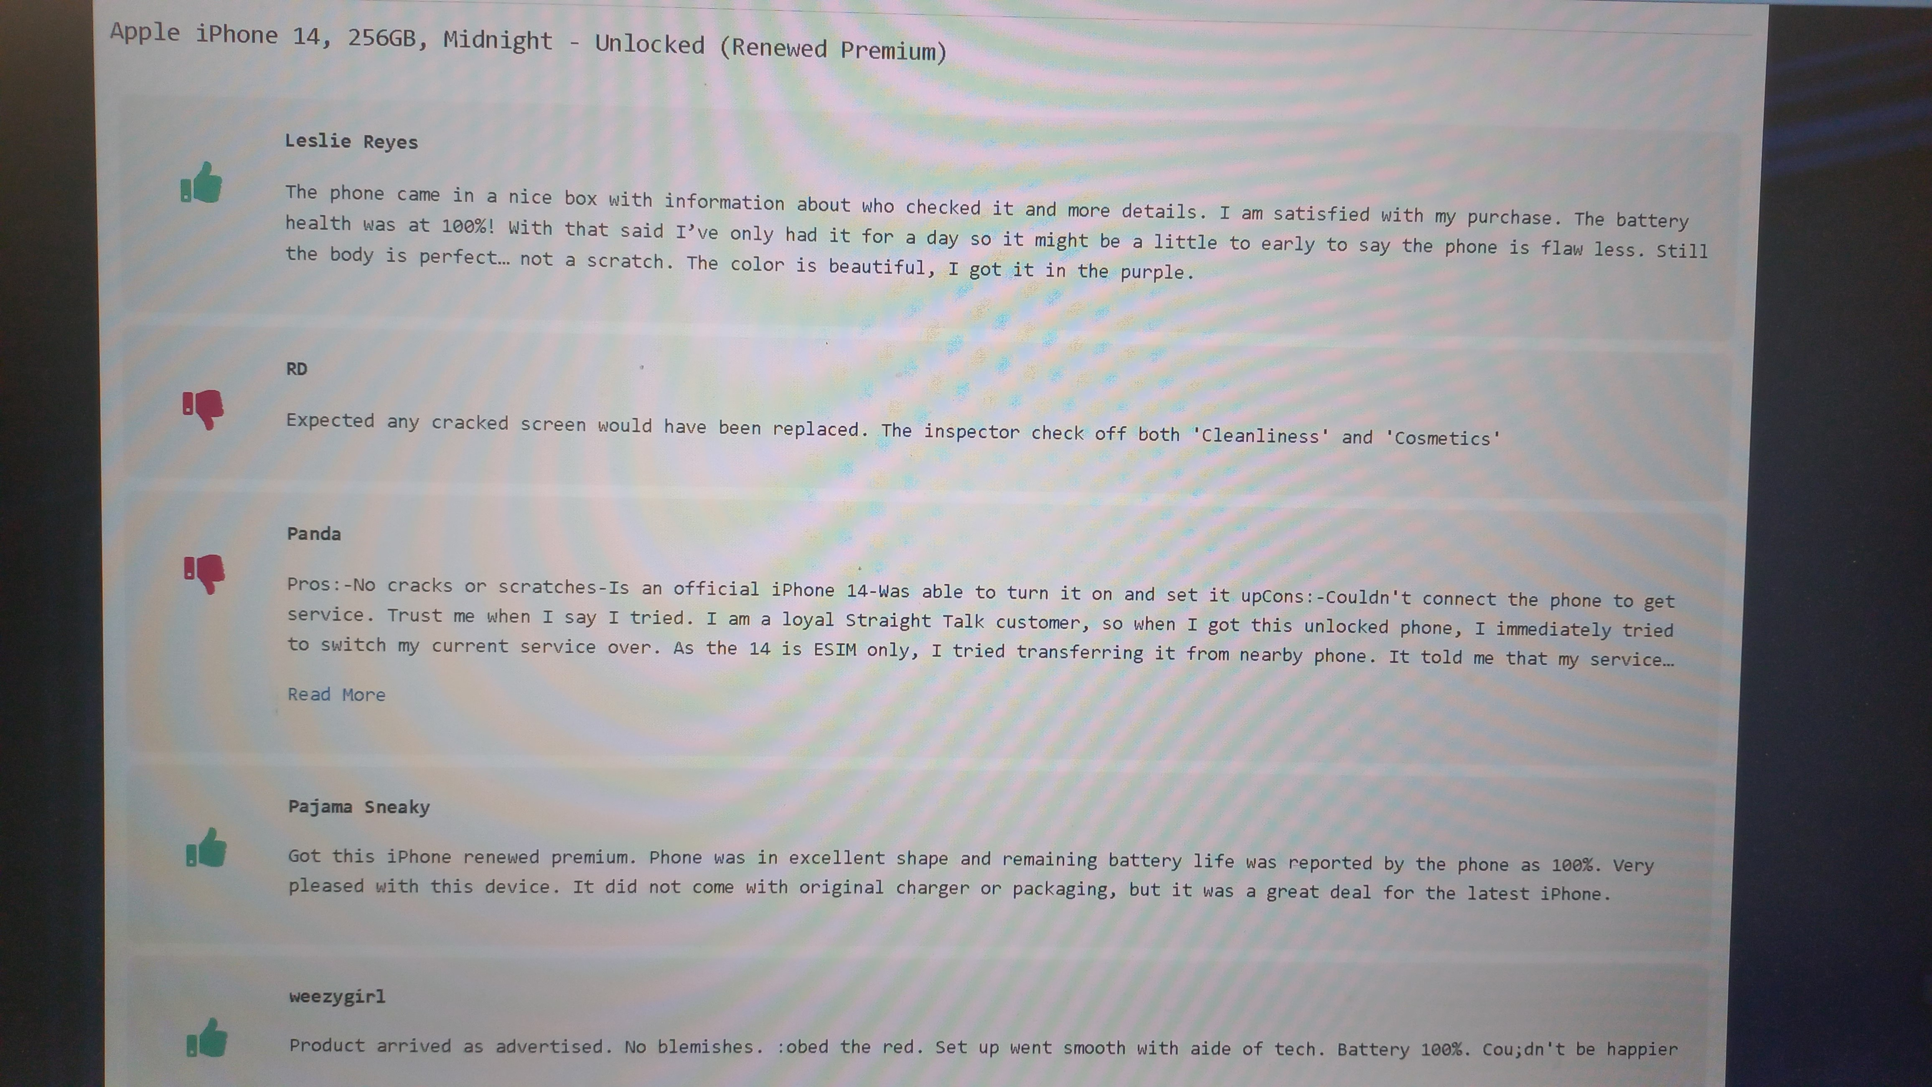

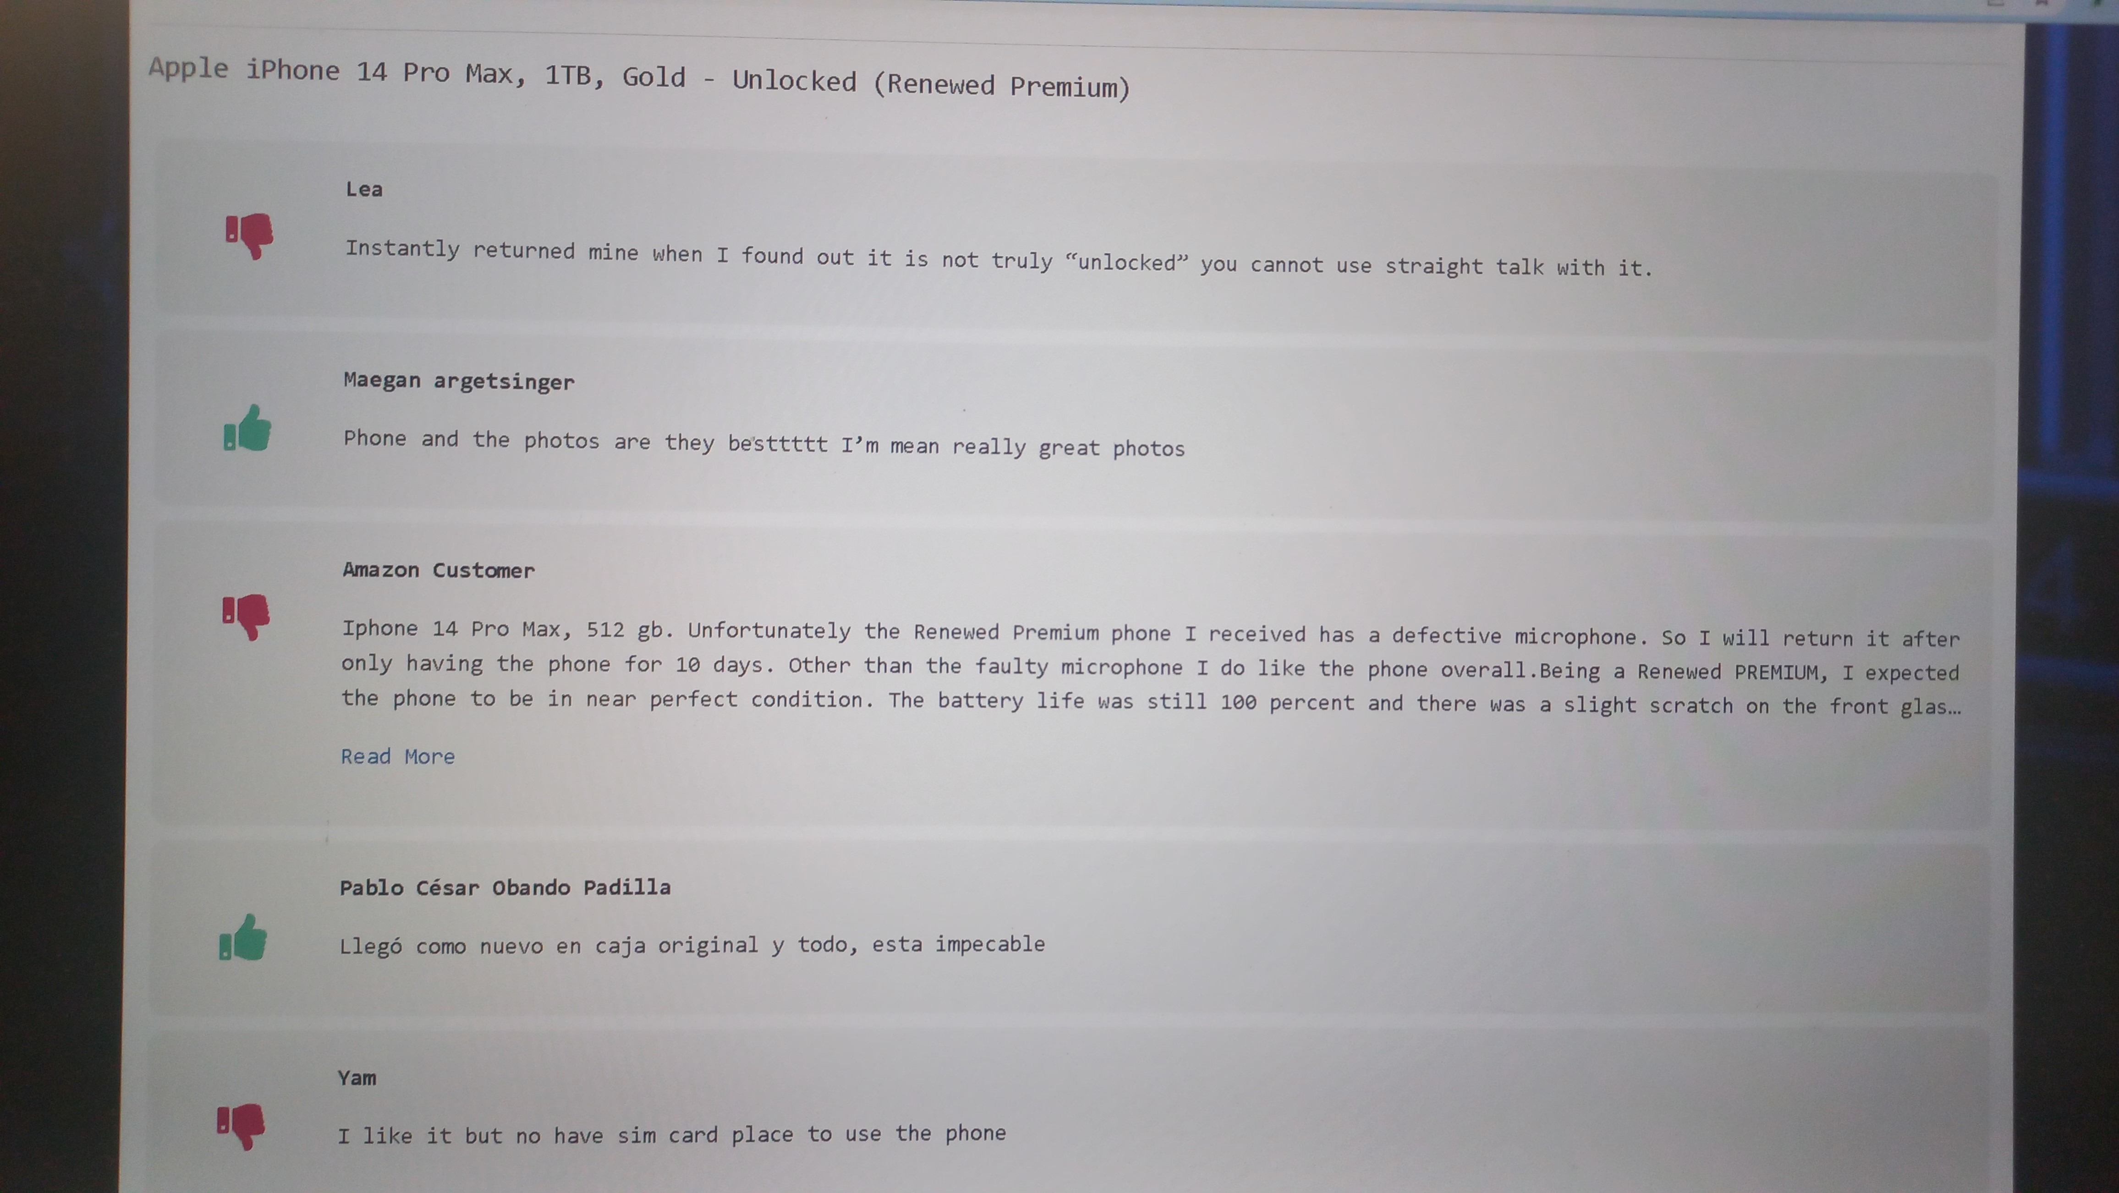

# Conclusion

We are delighted to announce that we have finished our sentiment analysis website project.

Our website offers you a simple and fast way to search for products, analyze their reviews, and view their details, thanks to our advanced web scraping techniques that minimize the search time and maximize the search quality.

We have used Flask, a web framework for Python, to create our website and to integrate various libraries and tools.

We have also explored some of the cutting-edge methods and models for sentiment analysis in NLP, and we have chosen linearSVC as our sentiment analysis model. But we are not stopping there.

We are always searching for ways to improve our website’s performance and accuracy, and we are constantly experimenting with different models and approaches.

We are also working hard to make our website more attractive and user-friendly, and to handle any errors or exceptions gracefully.

Moreover, we have used the open AI ChatGPT API to give us an analysis of the results of our model, which adds more depth and insight to our website. We are proud of our project, and we are delighted with our results.

We hope that our project will inspire others to create their own solutions, and that it will contribute to the advancement of sentiment analysis as a field.

We hope you love using our website as much as we loved creating it!